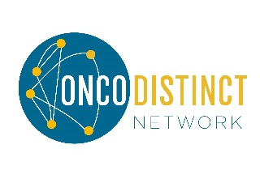
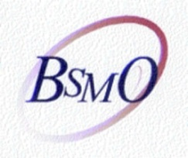
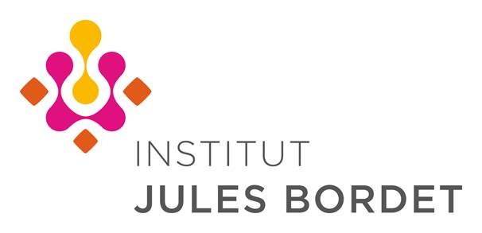

12th Belgian Symposium on the Integration of
Molecular Biology Advances into Oncology Clinical Practice
and
Post-MASCC 2018
23rd and 24th November 2018

First Name: Cliquez ici pour entrer du texte.  Hospital: Cliquez ici pour entrer du texte.  Email: Cliquez ici pour entrer du texte. | Family Name: Cliquez ici pour entrer du texte.  INAMI/RIZIV N°: Cliquez ici pour entrer du texte.

I will attend the Post-MASCC on Friday 23rd November from 9.00 to 12.30  I will attend the 12th Belgian symposium on Friday 23rd November from 14.00 to 18.00  I will attend the 12th Belgian symposium on Saturday 24th November from 8.00 to 12.30  I will attend the lunch on Friday 23rd November at 13.00  I will attend the lunch on Saturday 24th November at 13.00 | YES ☐ NO☐  YES ☐ NO☐  YES ☐ NO☐  YES ☐ NO☐  YES ☐ NO☐

Thank you for returning your response by mail: Jules Bordet Institute, Dr A. Awada – Rue Héger-Bordet 1, 1000 Bruxelles
By email: ahmad.awada@bordet.be or by fax: 00 32 2 541 33 39

