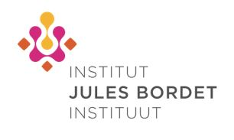

5th Human Cancer Immunology Course for Oncologists and Scientists Thursday 10 & Friday 11 October, 2019
Location : Pullman Brussels Centre Midi (Place Victor Horta 1, 1060 Brussels)

REPLY FORM
☐ Mr./Mrs ☐ Professor ☐ Doctor  First Name:  Hospital:  City : | INAMI/RIZIV n°:  Family Name:  Department :  Email:

I will attend on Thursday 10th October 2019  I will attend on Friday 11th October 2019 | YES ☐ NO☐  YES ☐ NO☐
Please return your response by August 20th to P. Adam (+32 (0) 2 541 32 06) by email: martine.piccart@bordet.be
For all information please contact P. Adam : +32 (0) 2 541 32 06 or martine.piccart@bordet.be
Institut Jules Bordet, Oncology Medicine Department 121 Boulevard de Waterloo 1000 Brussels

